**1.**

( a.) Display the path of your current directory

( b.) List out the contents of your current directory

( c.) List out the contents of your current directory including hidden files

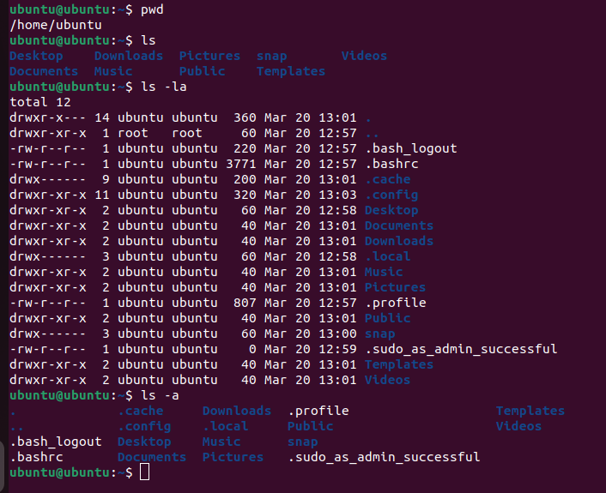

**2.**

( a.) Create a new directory named a

( b.) Move to the newly created directory a

( c.) Create a blank file named “file1”

( d.) Display the file type of “file1”

( e.) Add the line “Hello World” to “file1” using the command echo

( f.) Display the contents of “file1”

( g.) Display the file type of “file1” again**3.**

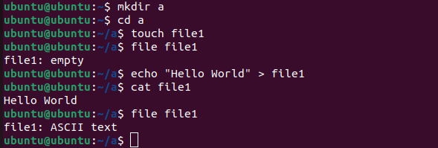

**3.**

( a.) Stay in directory a. Create a file “file2” and add the contents below using the command cat

***First Line Second Line Third Line***

( b.) Display the contents of “file2”

( c.) Display the contents of “file2” with the lines reversed

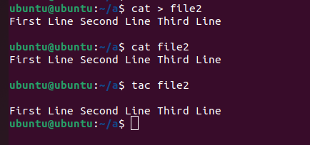

**4.**

( a.) Stay in directory a. Concatenate the contents of “file1” and “file2” and save them into a new file “file3”

( b.) Display the contents of “file3”

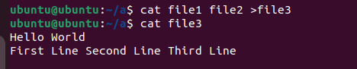

**5.**

( a.) Stay in directory a. Create 2 directories b/c with a single command

( b.) Create a new directory d

( c.) Copy the directory d to directory c using a single command

( d.) Delete the directory d in the current directory a

( e.) Copy “file3” to the directory d with a single command

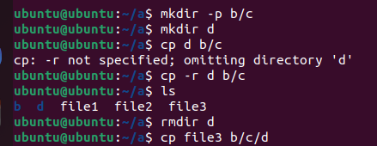

**6.**

( a.) Go to directory d and rename “file3” to “file0”

( b.) Stay in the same directory and move “file0” to directory a

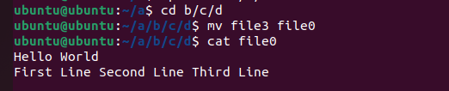

**7.**

( a.) Go to your home directory

( b.) Create a file named “test” in the directory a/b/c/d

( c.) Stay in the home directory. Find and display the path of “test”

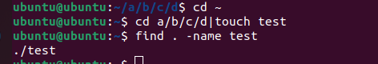

**8.**

( a.) Go to directory a. Get the man page of grep and save its contents to a file named “grepman.txt”

( b.) Print the lines containing the word “FILE” (Case sensitive) in the file “grepman.txt”

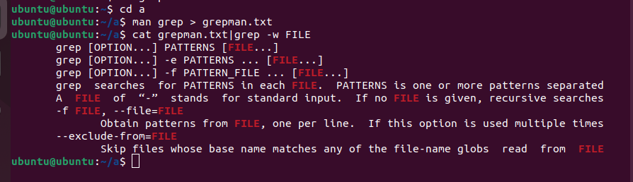

**9.**

**( a.)** Go to directory a and remove the directory b with a single command

**( b.)** Remove the files starting with the word “file” with a single

Command



**10.**

( a.) Download the compressed file from the drive. <https://drive.google.com/drive/folders/1PG3ZlpFu6nQSNjpCNuceoGcNey00bhPP?usp=sharing>

( b.) Extract the compressed file using CLI.

( c.) Decode the base64 content and display the content of “Flag.txt”using CLI.



**11**.

( a.) Go to <https://blog.bi0s.in/> and download the logo.png image using wget

( b.) Do the same using curl

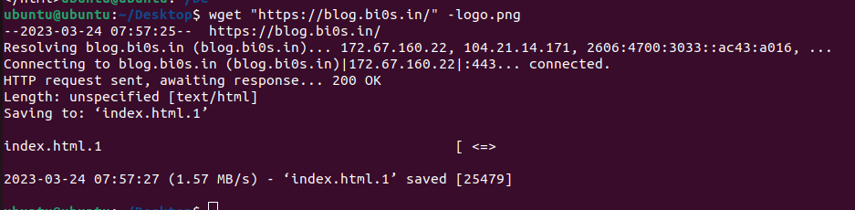

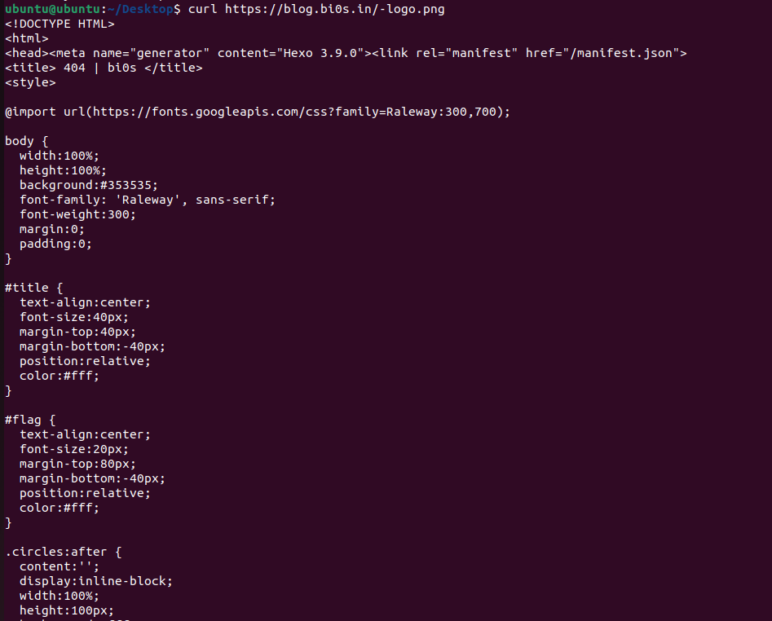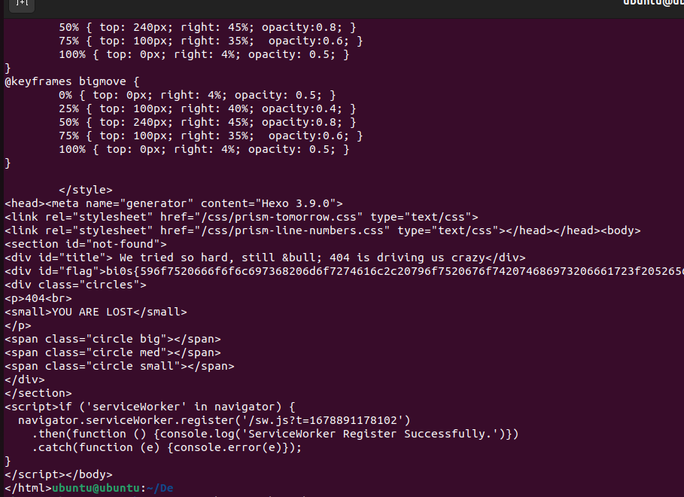

**12.**

**( a.)** Ping google.com and find the lowest time taken to get a response (Stop pinging after getting 5 responses)

**( b.)** Ping google.com 6 times and find the average time taken to get a response

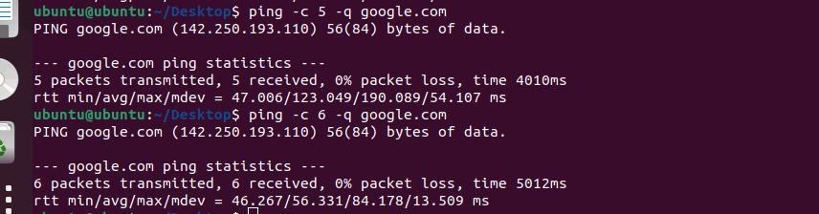

**13.**

Connect to your own system using telnet



**14.**

( a.) Learn about nmap and use that scanner to scan your own machine

( b.) Use nmap to scan scanme.nmap.org

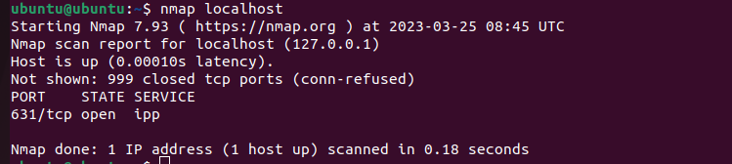

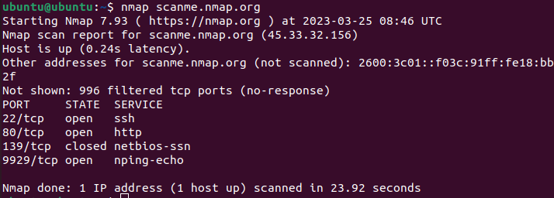

**15.**

( a.) Create a chat application using nc on your local machine with one terminal as server and other as the client

( b.) Transfer a file from server to client (save that file with another name) and display the file.

SERVER:

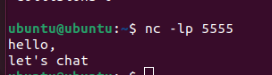

CLIENT:

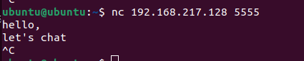

Server:



Client:

